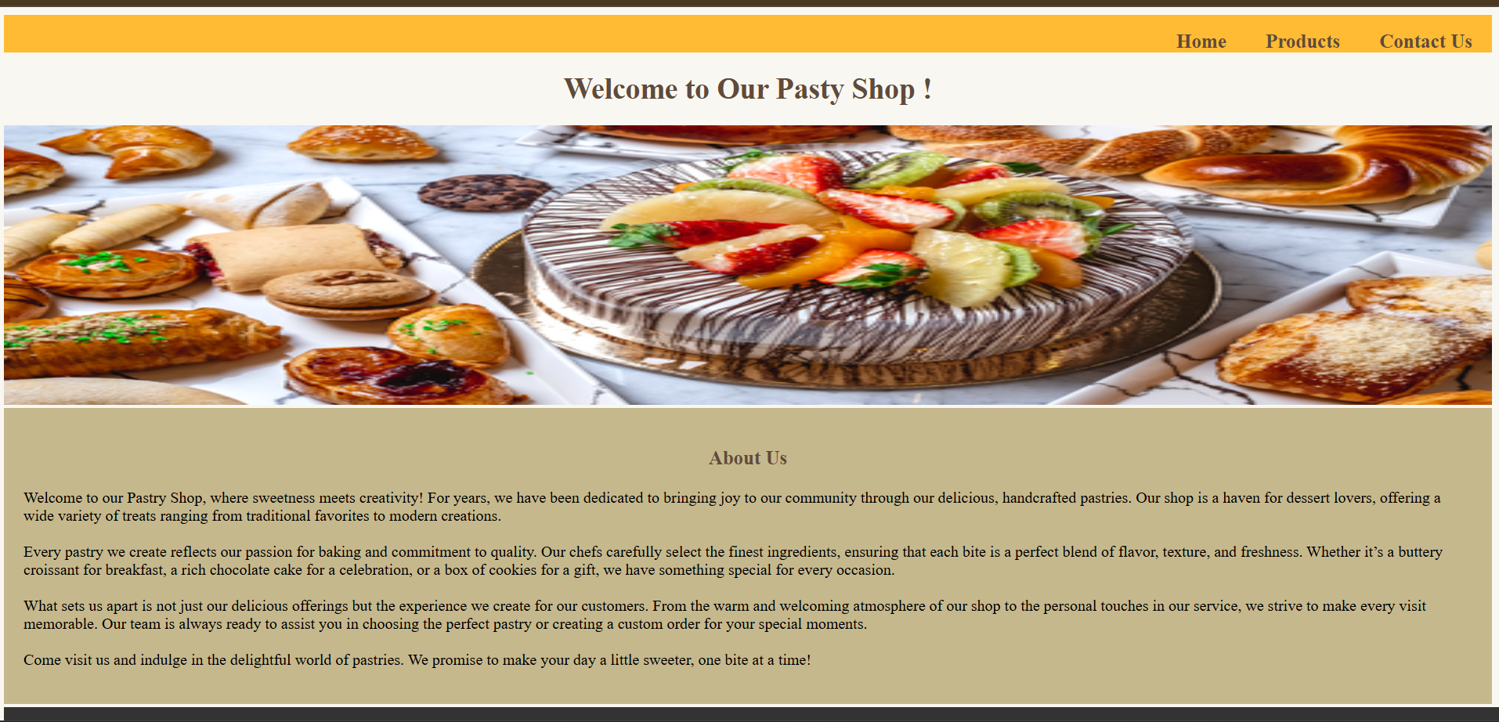

<!DOCTYPE html>

<html lang="en">

<head>

    <meta charset="UTF-8">

    <meta name="viewport" content="width=device-width, initial-scale=1.0">

    <title>Pastry Shop-Home</title>

    <link rel="stylesheet" href="Home.css">

</head>

<body style="background-color:  #f9f7f1;">

    <nav>

        <ul>

            <li><a href="ContactUs.html"><b>Contact Us</b></a></li>

            <li><a href="Product.html"><b>Products</b></a></li>

            <li><a href="Home.html"><b>Home</b></a></li>

        </ul>

    </nav>

    <h1>Welcome to Our Pasty Shop !</h1>

    <img src="home-banner.png">

    <div class="Aboutus">

        <h3> About Us</h3>

        <p>

            Welcome to our Pastry Shop, where sweetness meets creativity! For years, we have been dedicated to bringing

            joy to our community through our delicious, handcrafted pastries. Our shop is a haven for dessert lovers,

            offering a wide variety of treats ranging from traditional favorites to modern creations.<br><br>

            Every pastry we create reflects our passion for baking and commitment to quality. Our chefs carefully select

            the finest ingredients, ensuring that each bite is a perfect blend of flavor, texture, and freshness.

            Whether

            it’s a buttery croissant for breakfast, a rich chocolate cake for a celebration, or a box of cookies for a

            gift,

            we have something special for every occasion.<br><br>

            What sets us apart is not just our delicious offerings but the experience we create for our customers. From

            the warm and welcoming atmosphere of our shop to the personal touches in our service, we strive to make

            every visit memorable. Our team is always ready to assist you in choosing the perfect pastry or creating a

            custom order for your special moments.<br><br>

            Come visit us and indulge in the delightful world of pastries. We promise to make your day a little sweeter,

            one bite at a time!<br>

        </p>

    </div>

    <br><br>

    <footer class="footer">

        <p> &copy; 2025 The Pastry Shop. All Rights Reserved.</p>

      </footer>

</body>

</html>

 body{

    padding: 0px;

    margin: 0px;

 }

nav {

    background-color:#ffbb33;

    overflow: hidden;

}

nav ul li{

    display: inline-block;

    float: right;

    font-size: 20px;

}

nav a {

    color: #5f4b3a ;

    text-align: right;

    padding: 20px;

    text-decoration: none;

}

nav a:hover {

    background-color: #ddd;

    color: black;

}

h1{

    text-align: center;

    font-size: 30px;

    color:#5f4b3a  ;

}

img{

    width:100%;

   height: 380px;

}

.Aboutus {

    background-color: #c6b88d ;

    /* padding: 20px; */

    margin-top: 3px;

  padding: 10px;

}

h3{

    text-align: center;

    color:#5f4b3a  ;

    font-size: 20px;

}

.footer {

    background-color: #393737;

    color: white;

    text-align: center;

    padding: 1px;

    width: 100%;

    }

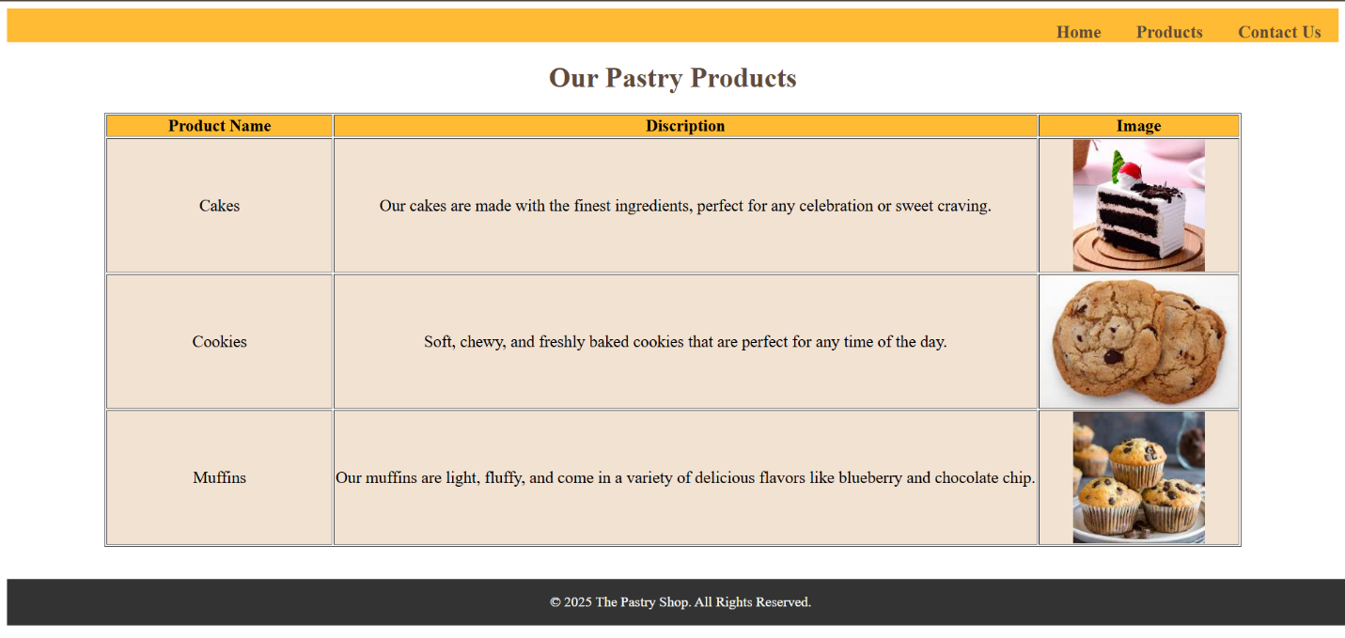

<!DOCTYPE html>

<html lang="en">

<head>

  <meta charset="UTF-8">

  <meta name="viewport" content="width=device-width, initial-scale=1.0">

  <title>Pastry Shop-Product</title>

  <link rel="stylesheet" href="Product.css">

</head>

<body style="background-color:  #ffffff ;">

  <nav>

    <ul>

      <li><a href="ContactUs.html"><b>Contact Us</b></a></li>

      <li><a href="Product.html"><b>Products</b></a></li>

      <li><a href="Home.html"><b>Home</b></a></li>

    </ul>

  </nav>

  <h1>Our Pastry Products</h1>

  <table border="1" style="text-align: center;">

    <tr style="background-color:#ffbb33 ;">

      <th style="width:20%">Product Name</th>

      <th>Discription</th>

      <th>Image</th>

    </tr>

    <tr style="background-color: #f2e2d2  ;">

      <td>Cakes</td>

      <td>Our cakes are made with the finest ingredients, perfect for any celebration or sweet craving.

      </td>

      <td><img src="cakes.jpg" width="100px"></td>

    </tr>

    <tr style="background-color:  #f2e2d2 ;">

      <td>Cookies</td>

      <td>Soft, chewy, and freshly baked cookies that are perfect for any time of the day.

      </td>

      <td><img src="cookies.jpg" width="100px"></td>

    </tr>

    <tr style="background-color:  #f2e2d2 ;">

      <td>Muffins</td>

      <td>Our muffins are light, fluffy, and come in a variety of delicious flavors like blueberry and chocolate chip.

      </td>

      <td><img src="muffins.jpg" width="100px"></td>

    </tr>

  </table>

  <br><br><br><br><br>

  <footer class="footer">

    <p>&copy; 2025 The Pastry Shop. All Rights Reserved.</p>

  </footer>

</body>

</html>

nav {

    background-color:#ffbb33;

    overflow: hidden;

}

nav ul li{

    display: inline-block;

    float: right;

    font-size: 20px;

}

nav a {

    color: #5f4b3a ;

    text-align: right;

    padding: 20px;

    text-decoration: none;

}

nav a:hover {

    background-color: #ddd;

    color: black;

}

h1{

    text-align: center;

    color: #5f4b3a;

}

table{

    font-size: 19px;

    margin: auto;

}

.footer {

    background-color: #333333;

    color: white;

    text-align: center;

    padding: 1px;

    position: fixed;

    width: 100%;

    }

 .footer{

    background-color:#333333 ;

    color: : #333333;

 }

 img{

    padding: 10px;

    border-radius: 5px;

 }

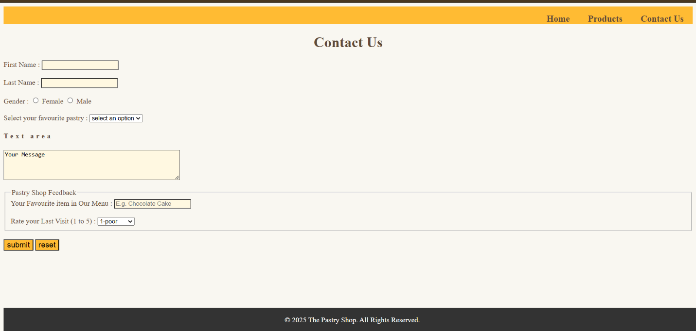

<!DOCTYPE html>

<html lang="en">

<head>

  <meta charset="UTF-8">

  <meta name="viewport" content="width=device-width, initial-scale=1.0">

  <title>Pastry Shop-Contact Us</title>

  <link rel="stylesheet" href="ContactUs.css">

</head>

<body style="background-color:  #f9f7f1 ;">

  <nav>

    <ul>

      <li><a href="ContactUs.html"><b>Contact Us</b></a></li>

      <li><a href="Product.html"><b>Products</b></a></li>

      <li><a href="Home.html"><b>Home</b></a></li>

    </ul>

  </nav>

  <h1>Contact Us</h1>

  <form action="/action_page.php">

    <label for="First Name">First Name :</label>

    <input type="text" id="First Name" style="background-color:  #fff8e1;"><br><br>

    <label for="Last Name">Last Name :</label>

    <input type="text" id="Last Name" style="background-color:  #fff8e1;"><br><br>

    <label for="Gender" style="cursor: pointer;">Gender :</label>

    <input type="radio" id="Female" value="Female" style="background-color:  #fff8e1;" name="gender">

    <lable for="Female" style="cursor: pointer;">Female</lable>

    <input type="radio" id="Male" value="Male" style="background-color:  #fff8e1;" name="gender">

    <lable for="Male" style="cursor: pointer;">Male</lable><br><br>

    <label for="pastry">Select your favourite pastry :</label>

    <select id="pastry">

      <option value="option">select an option</option>

      <option value="cakes">Cakes</option>

      <option value="cookies">Cookies</option>

      <option value="muuffins">Muffins</option>

    </select>

    <br>

    <h4>Text area</h4>

    <textarea name="message" rows="4" cols="50" style="background-color:  #fff8e1;">Your Message</textarea>

    <br><br>

    <fieldset>

      <legend>Pastry Shop Feedback</legend>

      <label for="Menu">Your Favourite item in Our Menu :</label>

      <input type="text" id="Menu" placeholder="E.g. Chocolate Cake" style="background-color:  #fff8e1;">

      <br><br>

      <label for="Rate"> Rate your Last Visit (1 to 5) :</label>

      <select id="rate">

        <option value="poor">1-poor</option>

        <option value="poor">2-good</option>

        <option value="poor">3-nice</option>

        <option value="poor">4-exellent</option>

        <option value="poor">5-great</option>

      </select>

    </fieldset>

    <br>

    <input type="button" value="submit" style="background-color:  #ffbb33; cursor: pointer; font-size: 17px;">

    <input type="button" value="reset" style="background-color:  #ffbb33;cursor: pointer;font-size: 17px;">

  </form>

  <br>

  <br><br><br><br><br>

  <footer class="footer">

    <p>&copy; 2025 The Pastry Shop. All Rights Reserved.</p>

  </footer>

</body>

</html>

h1,form{

    color:  #5f4b3a ;

}

nav {

    background-color:#ffbb33;

    overflow: hidden;

}

nav ul li{

    display: inline-block;

    float: right;

    font-size: 20px;

}

nav a {

    color: #5f4b3a ;

    text-align: right;

    padding: 20px;

    text-decoration: none;

}

nav a:hover {

    background-color: #ddd;

    color: black;

}

h1{

    text-align: center;

    color: #5f4b3a;

}

.footer {

    background-color: #333333;

    color: white;

    text-align: center;

    padding: 1px;

    position: fixed;

    width: 100%;

    }

    h4{

        letter-spacing: 5px;

    }